Chapter Four

Results

# Social Demographics

The illustrated below provides the distribution in percentage proportions of social demographic characteristics of respondents frequenting the Umoja refugee camp.

Table 1: Social Demographic Characteristics of Respondents Frequenting Umoja Refugee Camp

| **Social Demographic Characteristics** | **Frequency (%)** |
| --- | --- |
| Age |  |
| 18 - 24 years | 32 (19%) |
| 25 - 31 years | 60 (35%) |
| 32-38 years | 44 (26%) |
| 39 - 45 years | 25 (15%) |
| Above 45 years | 9 (5.3%) |
| Gender |  |
| Female | 105 (62%) |
| Male | 65 (38%) |
| Marital status |  |
| Single | 60 (35%) |
| Married | 80 (47%) |
| Widowed | 3 (1.8%) |
| Single mother | 19 (11%) |
| Separated | 8 (4.7%) |
| Education Level |  |
| No formal education | 11 (6.5%) |
| Primary | 27 (16%) |
| Secondary | 98 (58%) |
| Tertiary | 34 (20%) |
| Occupation |  |
| Casual worker | 57 (34%) |
| Employed | 19 (11%) |
| No income generating activity | 26 (15%) |
| Sel-employed | 24 (14%) |
| Small-scale business | 32 (19%) |
| Unemployed | 12 (7.1%) |
| Residence period |  |
| 2 - 5 years | 40 (24%) |
| 6 - 9 years | 59 (35%) |
| Over 10 years | 71 (42%) |
| Nationality |  |
| Burundian | 69 (41%) |
| Congolese | 35 (21%) |
| Rwandese | 58 (34%) |
| South Sudanese | 5 (2.9%) |
| Sundanese | 1 (0.6%) |
| Ugandan | 2 (1.2%) |

## Age group

The respondents frequenting Umoja refugee camp belonged to the 18 to 31 years old (54%) age group, followed by 32 to 48 (26%) age group and the 39 to 45 years olds (15%) while those above 45 years old only comprised 5.3% of all respondents. The results indicate that most refugees are young people between the ages of 18 and 30 years. People who flee from most countries seeking opportunities or asylum are largely young people, followed by middle aged refugees while only a small proportion of elderly people leave their countries due to conflict or search of better lives and opportunities.

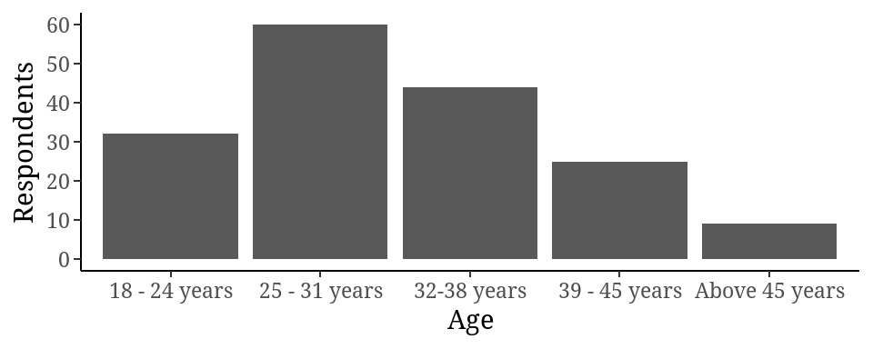

Figure 2: The distribution of age groups among refugees frequenting Umoja refugee camp

## Gender

The majority of the refugee respondents frequenting the camp were women or female (62%) compared to men (38%). The first people to leave any locations of crises are women and children while men are left behind fighting in the wars, managing the conflicts or resolving the conflicts. Therefore, most men are left behind and only a few men accompany the women and children in seeking asylum or refugee status in foreign countries. The results are therefore, in agreement with the general pattern of movement in times of crises.

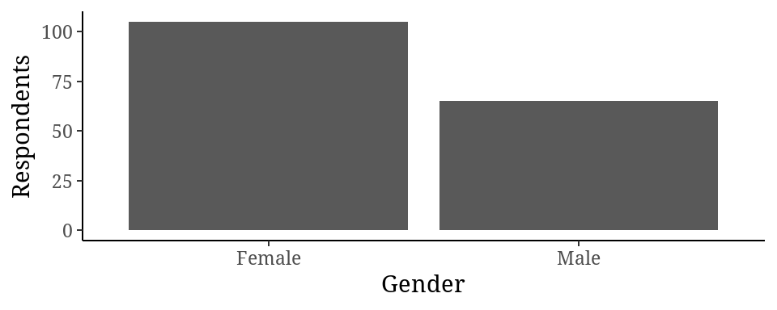

Figure 3: Gender distribution of respondents frequenting Umoja refugee camp

## Marital Status

The married respondents were more than other groups of people since they were represented by 47% of all foreigners frequenting the camp at Umoja followed by single or unmarried people at 35%. The single mother’s group comprised 11% of all respondents while the separated were 4.7% and widowed 1%. The age groups of the represented refugees controlled the marital status of the group; thus, explaining the low percentages for the separated and the widowed and single parents while the married and the single individuals making up the majority 82% of the respondents.

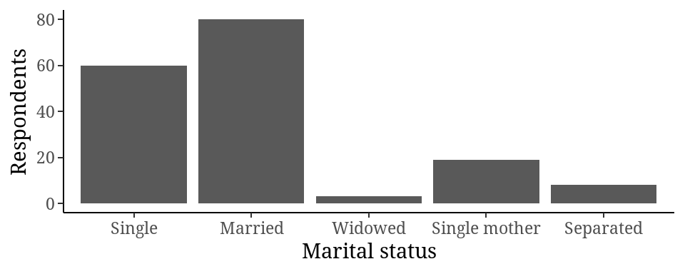

Figure 4: Marital Status of respondents frequenting Umoja refugee camp

## Level of education

The majority of the respondents (58%) had achieved secondary education as their highest academic excellence followed by 20% of respondents with tertiary education level and 16% with primary education level. Only 6.5% of the respondents lacked any formal education or training.

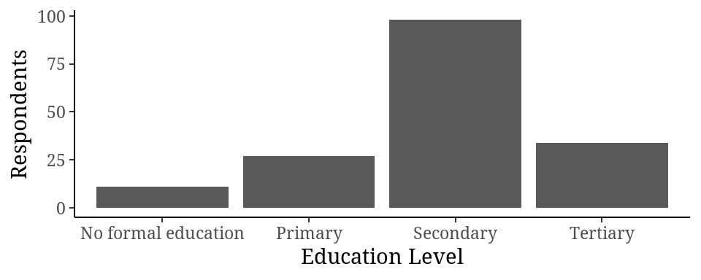

Figure 5: Education level of respondents frequenting the Umoja refugee camp

## Occupation

Casual workers comprised 34% of the respondents closely followed by small business entrepreneurs 33%. The unemployed and those not engaging in any income generating activity comprised 22% of the respondents while only 11% were formally employed.

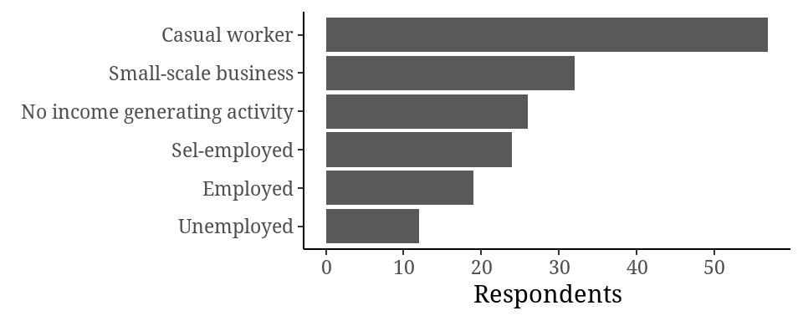

Figure 6: The occupation of respondents frequenting Umoja refugee camp

## Residence

The residence time as illustrated showed that 42% of the respondents had been living in Kenya for over 10 years, 35% above 5 years but less than 10 years while 24% of the respondents had been living in Kenya for a period of less than five years. The age groups selected for this study were above 18 years old, bearing in mind that most people flee their countries as children, then the residence time must have been above 10 years. Most of the conflicts in the neighbouring countries happened almost 10 years ago besides the ongoing conflicts in the region.

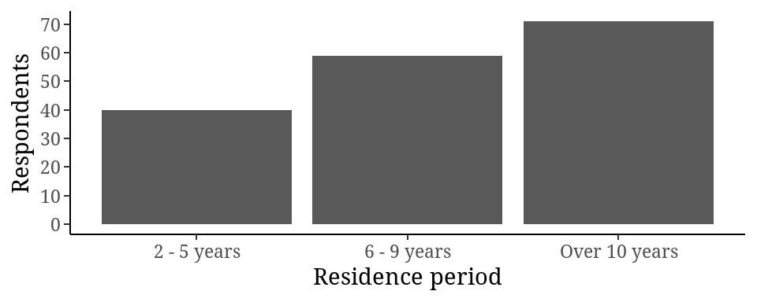

Figure 7: The duration that respondents had been living in Kenya

## Nationality

The largest proportion of respondents frequenting Umoja refugee camp were from Burundi (41%), followed by those from Rwanda (34%), then Congo (21%). Smaller proportions came from Sudan and South Sudan and Uganda at 2.9%, 1.2% and 0.6% respectively.

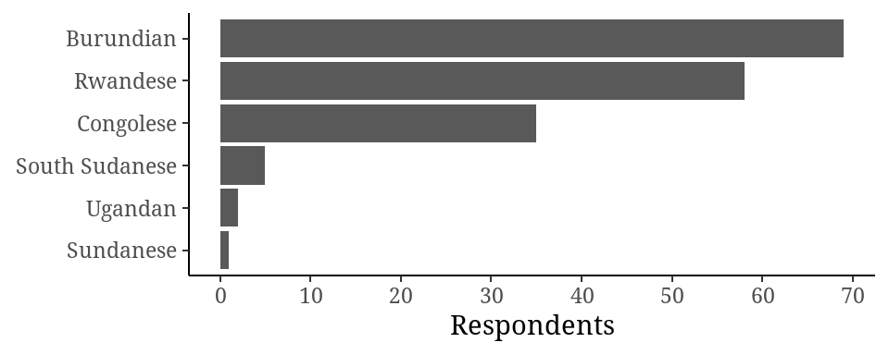

Figure 8: The distribution of nationalities of respondents frequenting Umoja refugee camp

## Prevalence of General Anxiety Disorder

The prevalence of general anxiety disorder was as illustrated in the table below; the majority of the respondents reported mild anxiety (64%) as 28% of the respondents reported moderate anxiety while only 2 individuals making up 1.2% of all respondents registered severe anxiety disorder, nevertheless, only 7.1% of the respondents were reported to be normal or to exhibit minimal anxiety. The illustration indicated presence of anxiety among foreigners or refugees which could have several precipitating factors.

Table 2: Prevalence of General Anxiety Disorder

| **General Anxiety Disorder** | **Prevalence of General Anxiety Disorder** |
| --- | --- |
| Minimal Anxiety | 12 (7.1%) |
| Mild Anxiety | 108 (64%) |
| Moderate Anxiety | 48 (28%) |
| Severe Anxiety | 2 (1.2%) |

# Prevalence of General Anxiety Disorder Across Social Demographic Factors

### General Anxiety Disorder Scores Across Age groups

Respondents between 32 and 45 years had the highest mean anxiety score (9.04 (3.59)), followed by respondents above 45 years old with 8.67 (3.94) mean anxiety score, which was followed by 25- to 31-year-olds with 8.27 (2.47) mean anxiety scores. Respondents between 18 and 24 years had the lowest mean anxiety score 7.34 (2.70), followed by 32- to 38-year-olds 7.84 (3.06). The results indicate that all age groups reported a mild level of anxiety. There was no statistical difference in anxiety scores across the age groups (p = 0.5, ns, anova)

| **General Anxiety** | **18 - 24 years** | **25 - 31 years** | **32-38 years** | **39 - 45 years** | **Above 45 years** | **p-value** |
| --- | --- | --- | --- | --- | --- | --- |
| GAD SCORE | 7.34 (2.70) | 8.27 (2.47) | 7.84 (3.06) | 9.04 (3.59) | 8.67 (3.94) | 0.5 |

### General Anxiety Disorder Scores Across Gender

The results as illustrated below indicated that women had higher anxiety mean scores 8.33 (3.22) than men 7.77 (2.43) although both were mild anxiety and thus not statistically significant (p = 0.2, ns, t-test).

| **General Anxiety** | **Female**, N = 105 | **Male**, N = 65 | **p-value** |
| --- | --- | --- | --- |
| GAD SCORE | 8.33 (3.22) | 7.77 (2.43) | 0.2 |

### General Anxiety Disorder Scores Across Marital status

Respondents from all marital status reported mild anxiety with the separated, single mothers and the married registering higher mean scores than the single and the widowed. The anxiety mean scores across marital status were not statistically significant (p=0.085, ns, anova).

| General Anxiety | **Single**, N = 60 | **Married**, N = 80 | **Widowed**, N = 3 | **Single mother**, N = 19 | **Separated**, N = 8 | **p-value** |
| --- | --- | --- | --- | --- | --- | --- |
| GAD Score | 7.33 (2.34) | 8.29 (3.08) | 7.67 (0.58) | 9.47 (3.88) | 9.25 (2.38) | 0.085 |

### General Anxiety Disorder Scores Across Education Level

Respondents with tertiary education reported the lowest anxiety mean score 7.09 (3.65) while primary educated and respondents without formal education had the highest mean anxiety scores 9.07 (3.44), the anxiety scores were not statistically significant across the education level (p = 0.2, ns, anova).

| **General Anxiety** | **No formal education**, N = 11 | **Primary**, N = 27 | **Secondary**, N = 98 | **Tertiary**, N = 34 | **p-value** |
| --- | --- | --- | --- | --- | --- |
| GAD Scores | 9.00 (1.90) | 9.07 (3.44) | 8.11 (2.52) | 7.09 (3.65) | 0.2 |

### General Anxiety Disorder Scores Across Occupation

Individuals without any income generating activity had the highest anxiety scores 9.23 (2.35) followed by casual workers and small business owners, 8.25 (2.20), while the employed had the lowest anxiety mean scores 6.84 (3.66). The mean scores were statistically insignificant across occupations (p=0.089, ns, anova).

| General anxiety | **Casual worker**, N = 57 | **Employed**, N = 19 | **No income generating activity**, N = 26 | **Sel-employed**, N = 24 | **Small-scale business**, N = 32 | **Unemployed**, N = 12 | **p-value** |
| --- | --- | --- | --- | --- | --- | --- | --- |
| GAD Score | 8.42 (2.67) | 6.84 (3.66) | 9.23 (2.35) | 7.33 (3.29) | 8.25 (2.20) | 7.50 (4.27) | 0.089 |

### General Anxiety Disorder Scores Across Residence Period

The statistical tests indicated that no matter the time an individual had been in Kenya as a refugee, the levels anxiety was the same statistically (p = 0.7, ns, anova). However, individuals who had stayed longer in Kenya reported higher anxiety scores.

| **General Anxiety** | **2 - 5 years**, N = 40 | **6 - 9 years**, N = 59 | **Over 10 years**, N = 71 | **p-value** |
| --- | --- | --- | --- | --- |
| GAD scores | 7.98 (2.65) | 8.19 (2.15) | 8.14 (3.63) | 0.7 |

### General Anxiety Disorder Scores Across Nationality

Respondents from Burundi, Congo and Rwanda exhibited higher levels of general anxiety compared to other nationalities represented.

| **General Anxiety** | **Burundian**, N = 69 | **Congolese**, N = 35 | **Rwandese**, N = 58 | **South Sudanese**, N = 5 | **Sundanese**, N = 1 | **Ugandan**, N = 2 | **p-value** |
| --- | --- | --- | --- | --- | --- | --- | --- |
| GAD score | 8.19 (2.94) | 8.31 (2.26) | 7.91 (3.46) | 7.40 (1.52) | 9.00 (NA) | 9.50 (2.12) | 0.7 |

# Precipitating Factors

The lack of refugee status and solutions, lack of income and income generating activities, lack of places to reside, issues regarding immigration, lack of basic needs which relates to the lack of income, improper documentation due to lack of refugee solutions were the greatest precipitating factors of general anxiety disorder where more than 90% of the refugees frequenting the Umoja refugee camp faced. Insecurity was only a concern to 70% and language barrier to 76% of the respondents and risks to relationship only cause anxiety to 66% of the refugees frequenting Umoja refugee camp. Discrimination was not a concern to the majority of the respondents (69%).

Table 4: Precipitating Factors of anxiety

| **Anxiety Precipitating Factors** | **Causing Anxiety** | **Not Causing Anxiety** |
| --- | --- | --- |
| Uncertainty | 163 (96%) | 7 (4.1%) |
| Homesickness | 156 (92%) | 14 (8.2%) |
| Lacking basic needs | 165 (97%) | 5 (2.9%) |
| Relationships lack | 112 (66%) | 58 (34%) |
| Immigration issues | 164 (96%) | 6 (3.5%) |
| Improper documentation | 153 (91%) | 16 (9.5%) |
| Insecurity | 119 (70%) | 51 (30%) |
| Lack of residence | 165 (97%) | 5 (2.9%) |
| Discrimination | 53 (31%) | 117 (69%) |
| Language barrier | 130 (76%) | 40 (24%) |
| Lack refugee solutions | 168 (99%) | 2 (1.2%) |
| No income | 167 (98%) | 3 (1.8%) |

# Community based interventions

There are several community-based interventions that are exercised within the Umoja Refugee camp. The most effective interventions at the refugee camp included individual counselling (64%), provision of food and basic needs (85%), social support from visitors (79%) and psychological trainings. The interventions are effective at medium proportions include guidance from leadership (43%), development of skills and talents and provision of job opportunities at 45%, 39% and 33% of the respondents. The interventions either not employed are ineffective include provision of school fees and uniforms (13%) and group counselling (14%).

| **Community-Based Interventions** | **Not Satisfied** | **Satisfied** |
| --- | --- | --- |
| Individual counselling | 62 (36%) | 108 (64%) |
| Group counselling | 147 (86%) | 23 (14%) |
| Psychological trainings | 80 (47%) | 90 (53%) |
| Leader’s guidance | 97 (57%) | 73 (43%) |
| Handicraft tailoring training | 93 (55%) | 77 (45%) |
| Skills talent development | 104 (61%) | 66 (39%) |
| Food basic needs | 26 (15%) | 144 (85%) |
| Fees and uniforms | 148 (87%) | 22 (13%) |
| Visitor’s Social support | 36 (21%) | 134 (79%) |
| Job opportunities | 114 (67%) | 56 (33%) |

Chapter Four Summary

This study illustrated that there were more women than men in the Umoja refugee camp, more young people than elderly, most having resided in the country for more than ten years, the majority with secondary education, just a few with tertiary education training. Most of the respondents were casual workers, a few in employment while quite a chunk had no income generating activity. A third of the respondents reported or exhibited general anxiety disorder, which was more pronounced among women than men, among younger people than older people and higher among those without income generating activities compared to those with incomes. Among the precipitating factors, uncertainties, lack of necessities of life, improper documentation, immigration issues significantly caused anxiety among the respondents. The community-based interventions that seem to have an impact on the respondents included social support from the visitations, provisions of income generating activities, handicraft training and psychological trainings. Group counselling was not found to be effective or available as well provision of school fees and school uniforms.

Chapter Five

Discussion

This study reported that 29.2% of all respondents had moderate to severe anxiety, the prevalence therefore of anxiety could be said to be 29.2%. The reported prevalence is higher compared with a systematic review of anxiety disorders which reported a global anxiety prevalence between 10.6% and 16.6% (Somers et al., 2016). The prevalence was lower because the study did not consider specific circumstances such as refugees and conflicts or regional prevalence. Haller et al., (2014) conducted an in-depth review of general anxiety prevalence among world populations and reported a prevalence between 4.1% and 13.7%, a prevalence lower than the prevalence reported in this study. That study had similar weakness in that it did not consider individuals in special circumstances such as wars and conflicts. Several studies done without special circumstances of wars and conflicts reported very low prevalence of general anxiety disorder (Ahmad et al., 2018; Haller et al., 2014; Martín-Merino et al., 2009; Ruscio et al., 2017; Spitzer et al., 2020.). A study done by Georgiadou et al., (2018) on mental distress among Syrian refugees in Germany, reported that 13.5% of all respondents had moderate to severe general anxiety disorder. The study by Georgiadou et al., (2018) reports lower prevalence than our study and the differences can be explained by amenities and support mechanisms provided to foreigners and refugees in the two different countries. Secondly, Kenya is a developing country while Germany is a first world country with capabilities of supporting asylum seekers and refugees. A study done by Kirmayer et al., (2011) indicated that immigrants to Canada usually have lower mental health disorders including general anxieties mainly due to screening done to foreigners before being admitted into the country. Another study conducted by Schlechter et al., (2021)indicated elevated anxiety compared to the general public among refugees and foreigners. A study on elucidation of mental health disorders among Rohingya refugees in Malysia Kaur et al., (2020) reported that 41% of all 200 participants had developed general anxiety disorder. This study had a higher prevalence than this study because the participants almost similar to those studied in Kenya. A review and meta-analysis conducted on refugees in high income countries Henkelmann et al., (2020) reported a 30% prevalence of general anxiety which is consistent with this study. Another study on mental health of immigrants due to armed conflict reported a 32% prevalence of general anxiety disorder (Mesa-Vieira et al., 2022), findings consistent with this study.

This study illustrated that the prevalence of anxiety was higher in women than men which is consistent with Shide, (2020.) and numerous other studies indicating higher mental health needs and disorders among women than men (Kaur et al., 2020; Pumariega et al., 2015). Kirmayer et al., (2021) reported that general anxiety disorders are higher among younger people than older people, the study is somewhat consistent with this study since the very young had the lowest anxiety while the middle aged had the highest anxiety scores and eldest had the lowest anxiety scores. Highly educated and skilful individuals have lower anxiety compared to individuals with only basic education and without any skills (Salami et al., 2019), a study consistent with the findings of this study.

A school of studies as illustrated above thus indicate a high prevalence of anxiety disorders among persons exposed to armed conflict or civil conflicts that lead to displacements of populations. The results of this study are consistent with most findings whenever a conflict is associated. The causes of anxiety are generally caused by a plethora of factors as illustrated in this study.

Among the precipitating factors of general anxiety are uncertainties, lack of income or income generating activities, homesickness, lack of refugee solutions, improper documentation, immigration issues and language barriers (Pumariega et al., 2015). The findings of this study on the precipitating factors of anxiety are consistent with a study done in Canada and Germany which reported that lack of support systems to foreigners and refugees significantly results to elevated levels of anxiety (Georgiadou et al., 2018; Kirmayer et al., 2011). Discrimination was not a concern among foreigners in this study but in developing world, racial and ethnic discrimination were pronounced and significantly increased anxiety levels from mild to moderate and severe (Georgiadou et al., 2018).

There are interventions meant to deal with general anxiety disorders among other mental heal disorders and needs that include use medicines, counselling, and community-based intervention (Salami et al., 2019). This study utilized community-based interventions as a means of combating mental health needs of refugees. The provision of social support and basic human needs such as food and shelter were the most effective community-based interventions according to refugees frequenting Umoja refugee camp. The findings of this study are consistent with (Georgiadou et al., 2018), who reported that social and economic support systems in Germany greatly reduced the suffering of foreigner after exposure to armed conflict. Rousseau & Frounfelker, (2019) reported on mental health needs and services for migrants among primary care givers and illustrated that language barriers and cultural differences greatly affected the delivery of care among refugees. The study thus recommended group counselling on acculturation which was conspicuously ineffective in this study and social support through visitations as practiced to refugees and foreigners in Umoja refugee camp.

Chapter Five Summary

The findings of this study were compared with study involving similar circumstances and themes and were found to be consistent with most literature. This chapter illustrated this in depth by use varied literature from diver regions of the world. The study compared anxiety disorder for literature not concerned with conflict whether armed, civil, or economic as well as literature concerning itself with anxiety disorder among immigrants due to exposure in armed conflict. The study found out that studies with a theme of armed conflict were consistent with finding of this study while general studies on anxiety disorders were distant from the findings of this study. Uncertainties in new countries and regions of the world exacerbated anxiety coupled with lack of basic needs due to lack of income generating activities. Most of the community-based interventions did not seem satisfactory to the respondents except for a few. Government support systems would likely be more effective compared to leaving the refugee burden upon the community. This finding is attested by a finding in Germany that dealt with refugees who had been granted permission to enter Germany after the Syrian crisis. Although the Germans only allowed trained and highly educated individuals to immigrate into Germany, thus the availability of government support system, their levels of anxiety were lower compared to those reported by this study.

References

Ahmad, M. M., Masalha, A. I. Al, Fayyomi, H., Mari’e, L. O., & Barghouti, F. F. (2018). Prevalence of generalized anxiety disorder in family practice clinics. *Clinical Practice*. https://doi.org/10.4172/clinical-practice.1000432

Georgiadou, E., Zbidat, A., Schmitt, G. M., & Erim, Y. (2018). Prevalence of mental distress among Syrian refugees with residence permission in Germany: A registry-based study. *Frontiers in Psychiatry*, *9*(AUG). https://doi.org/10.3389/fpsyt.2018.00393

Haller, H., Cramer, H., Lauche, R., Gass, F., & Dobos, G. J. (2014). The prevalence and burden of subthreshold generalized anxiety disorder: A systematic review. *BMC Psychiatry*, *14*(1). https://doi.org/10.1186/1471-244X-14-128

Henkelmann, J.-R., de Best, S., Deckers, C., Jensen, K., Shahab, M., Elzinga, B., & Molendijk, M. (2020). Anxiety, depression and post-traumatic stress disorder in refugees resettling in high-income countries: systematic review and meta-analysis. *BJPsych Open*, *6*(4). https://doi.org/10.1192/bjo.2020.54

Kaur, K., Sulaiman, A. H., Yoon, C. K., Hashim, A. H., Kaur, M., Hui, K. O., Sabki, Z. A., Francis, B., Singh, S., & Gill, J. S. (2020). Elucidating mental health disorders among rohingya refugees: A Malaysian perspective. *International Journal of Environmental Research and Public Health*, *17*(18), 1–22. https://doi.org/10.3390/ijerph17186730

Kirmayer, L. J., Narasiah, L., Munoz, M., Rashid, M., Ryder, A. G., Guzder, J., Hassan, G., Rousseau, C., & Pottie, K. (2011). Common mental health problems in immigrants and refugees: General approach in primary care. In *CMAJ. Canadian Medical Association Journal* (Vol. 183, Issue 12). Canadian Medical Association. https://doi.org/10.1503/cmaj.090292

Martín-Merino, E., Ruigómez, A., Wallander, M. A., Johansson, S., & García-Rodríguez, L. A. (2009). Prevalence, incidence, morbidity and treatment patterns in a cohort of patients diagnosed with anxiety in UK primary care. *Family Practice*, *27*(1), 9–16. https://doi.org/10.1093/fampra/cmp071

Mesa-Vieira, C., Haas, A. D., Buitrago-Garcia, D., Roa-Diaz, Z. M., Minder, B., Gamba, M., Salvador, D., Gomez, D., Lewis, M., Gonzalez-Jaramillo, W. C., Pahud de Mortanges, A., Buttia, C., Muka, T., Trujillo, N., & Franco, O. H. (2022). Mental health of migrants with pre-migration exposure to armed conflict: a systematic review and meta-analysis. *The Lancet Public Health*, *7*(5), e469–e481. https://doi.org/10.1016/S2468-2667(22)00061-5

Pumariega, A. J., Rothe, E., & Pumariega, J. A. B. (2005). Mental health of immigrants and refugees. In *Community Mental Health Journal* (Vol. 41, Issue 5, pp. 581–597). https://doi.org/10.1007/s10597-005-6363-1

Rousseau, C., & Frounfelker, R. L. (2019). Mental health needs and services for migrants: An overview for primary care providers. In *Journal of Travel Medicine* (Vol. 26, Issue 2). Oxford University Press. https://doi.org/10.1093/jtm/tay150

Ruscio, A. M., Hallion, L. S., Lim, C. C. W., Aguilar-Gaxiola, S., Al-Hamzawi, A., Alonso, J., Andrade, L. H., Borges, G., Bromet, E. J., Bunting, B., De Almeida, J. M. C., Demyttenaere, K., Florescu, S., De Girolamo, G., Gureje, O., Haro, J. M., He, Y., Hinkov, H., Hu, C., … Scott, K. M. (2017). Cross-sectional comparison of the epidemiology of DSM-5 generalized anxiety disorder across the globe. *JAMA Psychiatry*, *74*(5), 465–475. https://doi.org/10.1001/jamapsychiatry.2017.0056

Salami, B., Salma, J., & Hegadoren, K. (2019). Access and utilization of mental health services for immigrants and refugees: Perspectives of immigrant service providers. *International Journal of Mental Health Nursing*, *28*(1), 152–161. https://doi.org/10.1111/inm.12512

Schlechter, P., Wilkinson, P. O., Knausenberger, J., Wanninger, K., Kamp, S., Morina, N., & Hellmann, J. H. (2021). Depressive and anxiety symptoms in refugees: Insights from classical test theory, item response theory and network analysis. *Clinical Psychology and Psychotherapy*, *28*(1), 169–181. https://doi.org/10.1002/cpp.2499

Shide, H. M. (n.d.). *ANXIETY DISORDER AMONG WOMEN URBAN REFUGEES*.

Somers, J. M., Goldner, E. M., Waraich, P., & Hsu, L. (2006). Prevalence and Incidence Studies of Anxiety Disorders: A Systematic Review of the Literature. In *Can J Psychiatry* (Vol. 51, Issue 2).

Spitzer, R. L., Kroenke, K., Williams, J. B. W., & Löwe, B. (n.d.). *A Brief Measure for Assessing Generalized Anxiety Disorder The GAD-7*. https://jamanetwork.com/